**Network Topology Report**

**Prepared for:** Advanced Computer Networks

**Team Members:**

**Mohamed Saied Osman**

**Mohamed Hesham Abbas**

**Mahmoud Mohamed Mahmoud**

**Mohammed Hany Rafaat**

**Omar Mohamed Abduh**

**Introduction**

A network topology is a schematic representation of a network, outlining its physical and logical structure. This report delves into a segmented VLAN-based topology designed to ensure scalability, performance, and security for a multi-departmental network. Each department (Area) is segmented into its own VLANs with dedicated subnets and configured switch ports to support specific use cases.

This detailed report includes:

1. **Network Design Rationale**
2. **Detailed Area Configurations (VLANs and Subnets)**
3. **Switch Port Assignments**
4. **Routing and Inter-VLAN Communication**
5. **Trunk Links and Redundancy**
6. **Benefits of This Topology**

**1. Network Design Rationale**

The primary goals of this topology include:

* **Segmentation:** Each department is segmented into VLANs to isolate traffic for security and performance.
* **IP Address Efficiency:** IP subnets are tailored to the expected number of devices, ensuring optimal utilization.
* **Scalability:** The network is designed to allow the addition of new VLANs or devices without disrupting operations.
* **Centralized Management:** Trunk links and proper switch configurations allow centralized control of VLANs across switches.
* **Security:** By separating traffic, sensitive data from one department cannot be accessed by another without proper authorization.

**2. Detailed Area Configurations (VLANs and Subnets)**

**Area 1: A_01**

* **Purpose:** General office network with two main segments (e.g., Admin and Staff).
* **VLAN 1 (A_01.1):**
  + **Ports:** f0/5 - f0/14
  + **Subnet:** 172.22.0.0/27
  + **Subnet Mask:** 255.255.255.224
  + **Usable IP Range:** 172.22.0.1 to 172.22.0.30
  + **Gateway:** 172.22.0.1
  + **Broadcast Address:** 172.22.0.31
* **VLAN 2 (A_01.2):**
  + **Ports:** f0/15 - f0/24
  + **Subnet:** 172.22.0.32/27
  + **Subnet Mask:** 255.255.255.224
  + **Usable IP Range:** 172.22.0.33 to 172.22.0.62
  + **Gateway:** 172.22.0.33
  + **Broadcast Address:** 172.22.0.63
* **Trunk Ports:**
  + **Trunk Ports Assigned:** f0/1 - f0/4
  + **Purpose:** To allow VLAN traffic between switches for Area 1 and the core switch.

**1. VLAN 1 (A_01.1)**

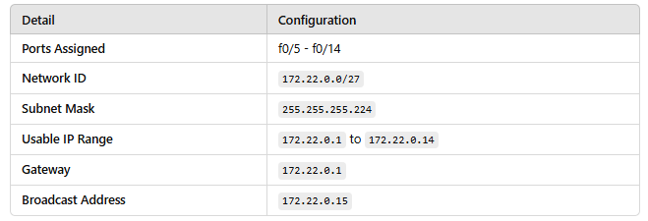

**Purpose:**

* VLAN 1 is assigned to the first group of devices or users in **Area 1**, ensuring that their traffic remains isolated from other VLANs.

**2. VLAN 2 (A_01.2)**

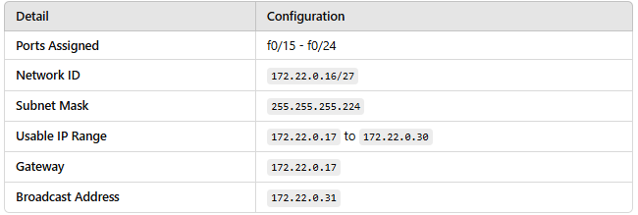

**Purpose:**

* VLAN 2 provides a separate segment for the second group of devices or users, isolating their traffic from VLAN 1 while enabling communication within its VLAN.

**3. Trunk Ports Configuration**

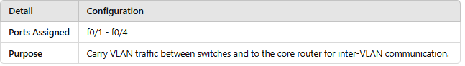

**Key Notes:**

1. **Tagged Traffic:** Trunk ports carry both VLAN 1 and VLAN 2 traffic with appropriate VLAN tagging.
2. **VLAN Encapsulation Protocol:** IEEE 802.1Q is used for tagging VLAN traffic.
3. **Inter-VLAN Routing:** A Layer 3 switch or router is required for routing between VLANs 1 and 2.

**Area 2: A_02**

* **Purpose:** Multi-department office with five VLANs (e.g., HR, IT, Finance, Sales, and Training).
* **VLAN Configurations:**

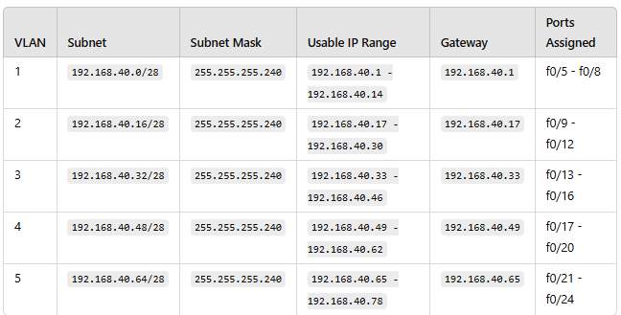

* **Trunk Ports:** 4 trunk ports to the core switch.

**Area 3: A_03**

**Purpose of Area 3:**

* **Network Segmentation:** Six VLANs are designed to separate traffic and reduce broadcast domains.
* **Optimized IP Addressing:** Smaller subnets (/28 and /30) ensure efficient use of IP addresses.
* **Scalability:** The configuration allows the addition of new VLANs or adjustment of existing ones.
* **Inter-VLAN Routing:** Trunk ports enable communication between VLANs through routing on a Layer 3 switch or router.

**1. VLAN A_03.1**

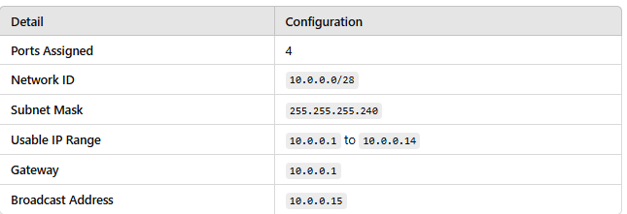

**2. VLAN A_03.2**

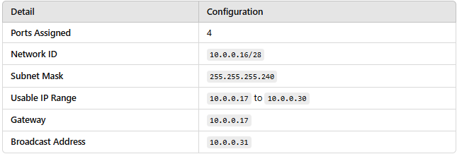

**3. VLAN A_03.3**

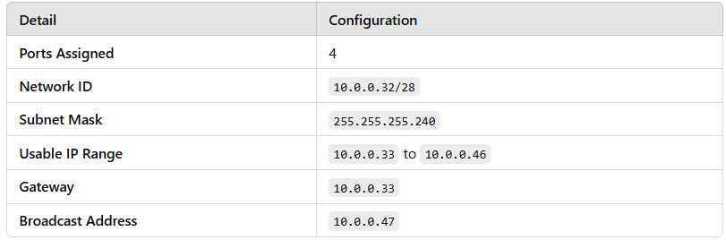

**4. VLAN A_03.4**

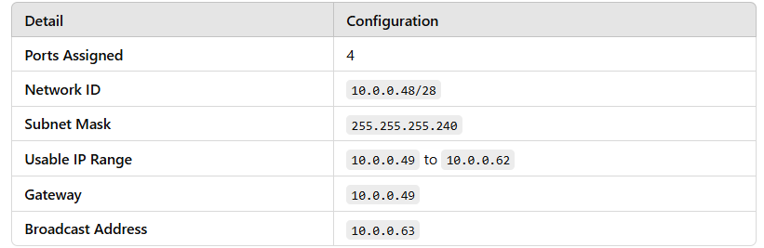

**5. VLAN A_03.5**

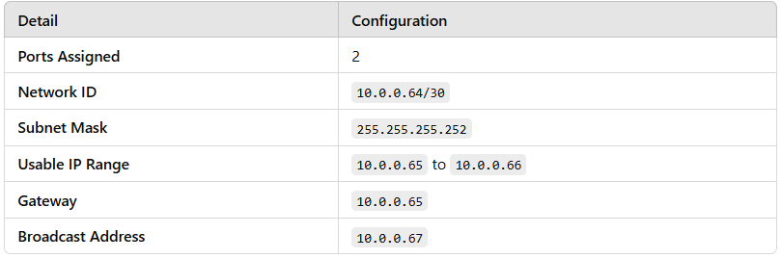

**6. VLAN A_03.6**

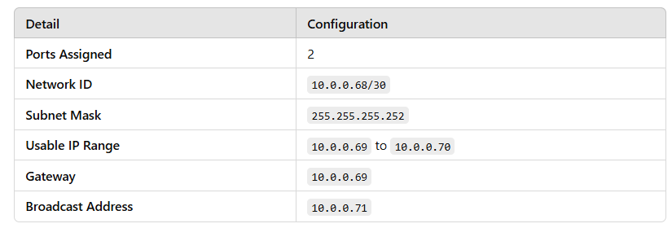

**Trunk Ports Configuration**

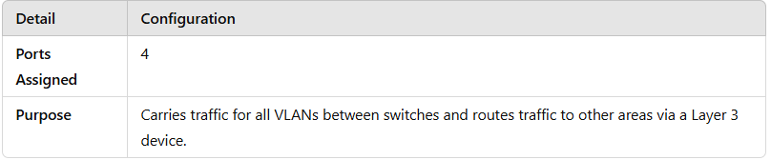

**Area 4: A_04**

**Purpose of Area 4:**

1. **Efficient Subnetting:** The use of /29 subnets ensures a balance between IP allocation and network efficiency for a small number of devices.
2. **Network Segmentation:** VLANs provide logical separation, reducing broadcast traffic and improving network performance.
3. **Optimized Resource Usage:** Each VLAN is precisely configured for the number of devices, avoiding waste of IP addresses.
4. **Scalability:** The design allows future expansion by adding VLANs or increasing port counts as necessary.
5. **Inter-VLAN Routing:** Trunk ports facilitate communication between VLANs and with other areas through routing.

**1. VLAN A_04.1**

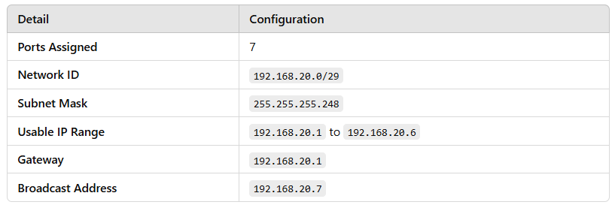

**2. VLAN A_04.2**

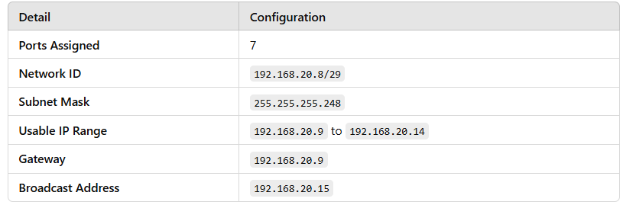

**3. VLAN A_04.3**

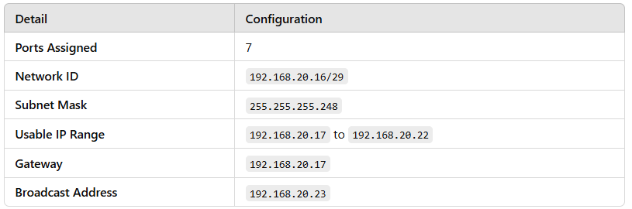

**Trunk Ports Configuration**

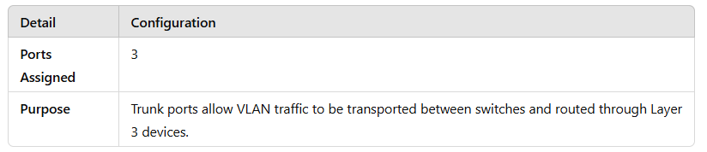

**Area 5 (A_05)**

**Purpose of Subnet Design:**

* **Efficient IP Allocation:** The /29 subnet mask ensures efficient use of the limited IP addresses available while supporting up to 6 devices per VLAN.
* **Isolation and Segmentation:** Each VLAN is designed to isolate specific groups of devices, improving security and network performance.
* **Scalability:** The subnetting allows easy addition of new VLANs or expansion of existing ones with minimal impact on other network sections.

**VLAN A_05.1**

* **Network:** 172.20.0.0/29
* **Usable IPs:** 172.20.0.1 to 172.20.0.6
* **Subnet Mask:** 255.255.255.248
* **Gateway:** 172.20.0.1
* **Broadcast Address:** 172.20.0.7

**Subnet Breakdown:**

* **Network Address:** 172.20.0.0
* **First Usable IP:** 172.20.0.1
* **Last Usable IP:** 172.20.0.6
* **Broadcast Address:** 172.20.0.7
* **Total Usable IPs:**6
  + This subnet provides a small range of IP addresses ideal for a few devices or specialized equipment.

**VLAN A_05.2**

* **Network:** 172.20.0.8/29
* **Usable IPs:** 172.20.0.9 to 172.20.0.14
* **Subnet Mask:** 255.255.255.248
* **Gateway:** 172.20.0.9
* **Broadcast Address:** 172.20.0.15

**Subnet Breakdown:**

* **Network Address:** 172.20.0.8
* **First Usable IP:** 172.20.0.9
* **Last Usable IP:** 172.20.0.14
* **Broadcast Address:** 172.20.0.15
* **Total Usable IPs:**6
  + Similar to VLAN A_05.1, this subnet has a small range and can be used for devices that need isolated network access.

**VLAN A_05.3**

* **Network:** 172.20.0.16/29
* **Usable IPs:** 172.20.0.17 to 172.20.0.22
* **Subnet Mask:** 255.255.255.248
* **Gateway:** 172.20.0.17
* **Broadcast Address:** 172.20.0.23

**Subnet Breakdown:**

* **Network Address:** 172.20.0.16
* **First Usable IP:** 172.20.0.17
* **Last Usable IP:** 172.20.0.22
* **Broadcast Address:** 172.20.0.23
* **Total Usable IPs:**6
  + This subnet provides the same number of IPs, ensuring the flexibility for isolated communication within this VLAN.

**VLAN A_05.4**

* **Network:** 172.20.0.24/29
* **Usable IPs:** 172.20.0.25 to 172.20.0.30
* **Subnet Mask:** 255.255.255.248
* **Gateway:** 172.20.0.25
* **Broadcast Address:** 172.20.0.31

**Subnet Breakdown:**

* **Network Address:** 172.20.0.24
* **First Usable IP:** 172.20.0.25
* **Last Usable IP:** 172.20.0.30
* **Broadcast Address:** 172.20.0.31
* **Total Usable IPs:**6
  + The IP range provided in this subnet is also intended for small-scale usage with limited devices in this VLAN.

1. **Routing and Inter-VLAN Communication**

To enable communication between VLANs and ensure that devices in different VLANs can exchange traffic, router is required for Inter-VLAN routing.

The process involves routing traffic based on the VLAN ID in the tagged frame. The configuration ensures that only authorized devices in different VLANs can communicate, maintaining network security and segregation while providing the flexibility of inter-VLAN communication when necessary.

* **Router-on-a-Stick Configuration**: A single physical interface on a router is configured as a trunk link, which carries multiple VLAN traffic. Subinterfaces are created on this interface, each corresponding to a VLAN, and each subinterface is assigned an IP address in the corresponding VLAN subnet.
* **Router Subinterfaces**: If a router is used for Inter-VLAN routing, subinterfaces are created for each VLAN. These subinterfaces are configured with IP addresses that correspond to the gateways for each VLAN. For example, if VLAN A_01.1 has the subnet 172.22.0.0/27, the router subinterface for VLAN 1 will be configured with the IP 172.22.0.1.
* **IEEE 802.1Q Trunking**: We configured all router subinterfaces to use IEEE 802.1Q encapsulation to carry traffic for multiple VLANs. The router or must be configured to support 802.1Q encapsulation on its trunk ports, enabling the identification of VLANs by their tags and ensuring that traffic from each VLAN is routed to the appropriate destination.

In this network design, **Inter-VLAN Routing** is handled by utilizing **OSPF (Open Shortest Path First)**, a dynamic routing protocol, to automatically exchange routing information between the routers and Layer 3 switches, ensuring adaptive and efficient routing within the network.